**Visvesvaraya Technological University, Belagavi**



## **MINI-PROJECT REPORT**

## **on**

### “EXPENSE TRACKING USING PYTHON”

**Submitted in the partial fulfillment of requirements for the completion of**

**MASTER OF COMPUTER APPLICATIONS**

Submitted By

NAME USN

**SAJITH THOMAS**  **4VP21MC038**

**GEETHANJALI 4VP21MC014**

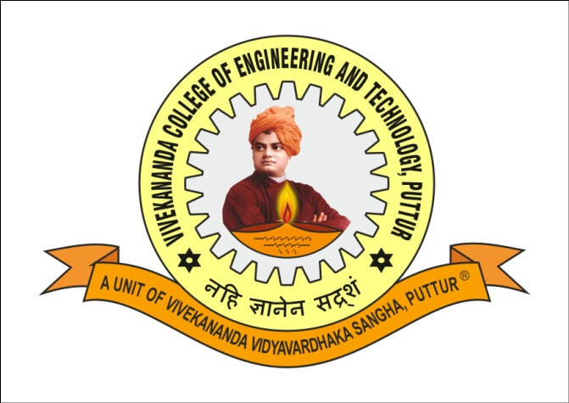

**DEPARTMENT OF MASTER OF COMPUTER APPLICATIONS**

**VIVEKANANDA COLLEGE OF ENGINEERING & TECHNOLOGY**

**NEHRU NAGARA, PUTTUR (D.K.) - 574 203**

**2022-23**